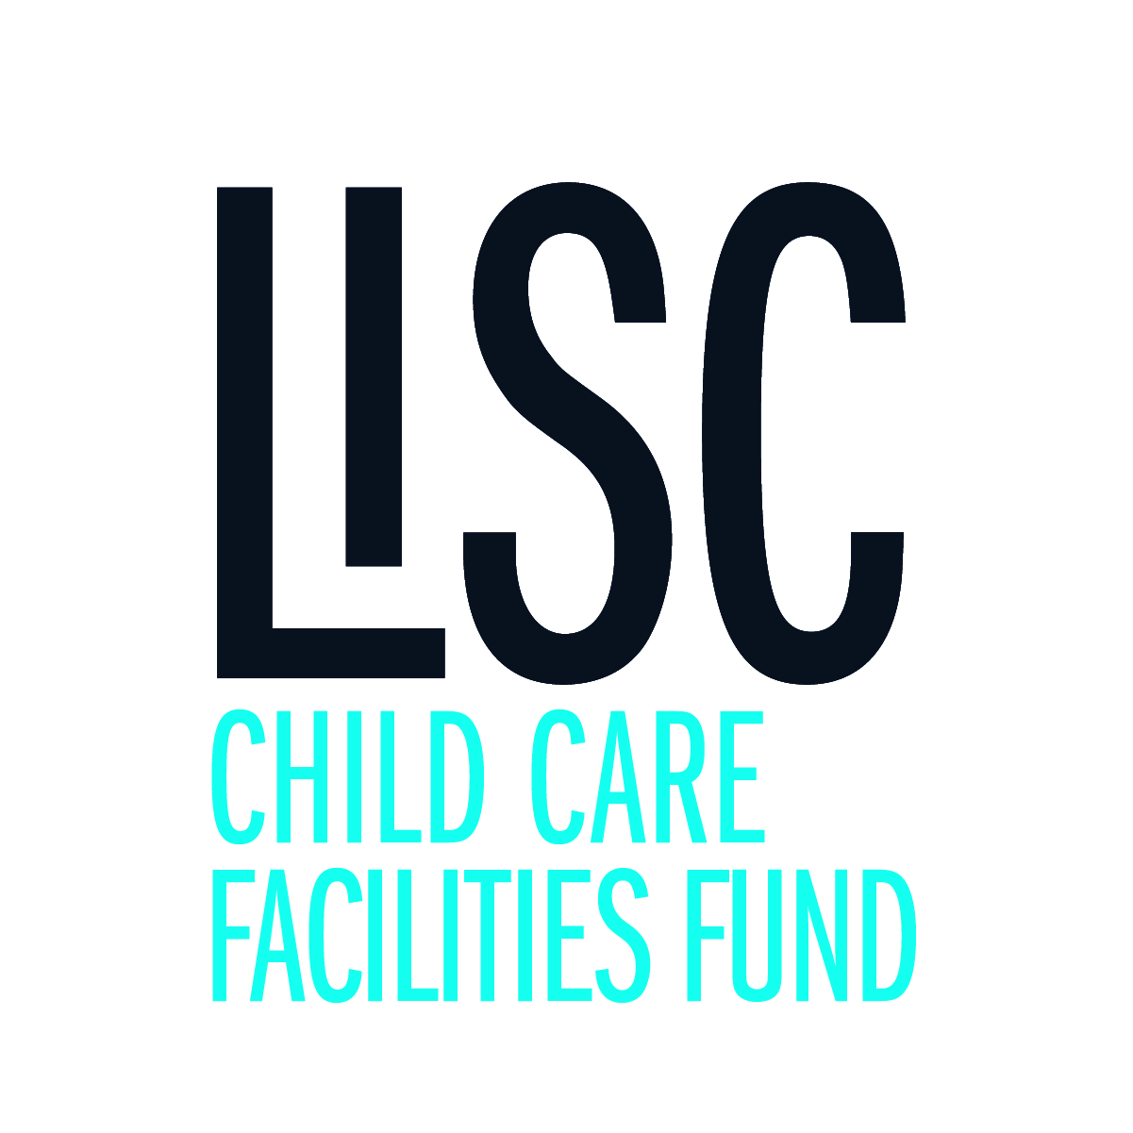

Narrative

Please type your narrative below and then save this file and upload as part of your application process. Be sure to answer all of the following items in the proposal narrative as incomplete applications will not be considered. Proposals should be no more than 4 pages in length.

1. Brief summary of your organization including mission, history, goals and key achievements:

Click or tap here to enter text.

1. Overview of organization’s structure and programs:

Click or tap here to enter text.

1. Summary of key leadership staff and board members including a summary of their qualifications:

Click or tap here to enter text.

1. Describe your proposed project and its impact on program health, safety, or quality:

Click or tap here to enter text.

1. Describe your capacity plan to complete the project within the allowed time frame:

Click or tap here to enter text.

1. Describe your plan to solicit minority- and women-owned businesses when hiring professionals for proposed grant-funded work:

Click or tap here to enter text.