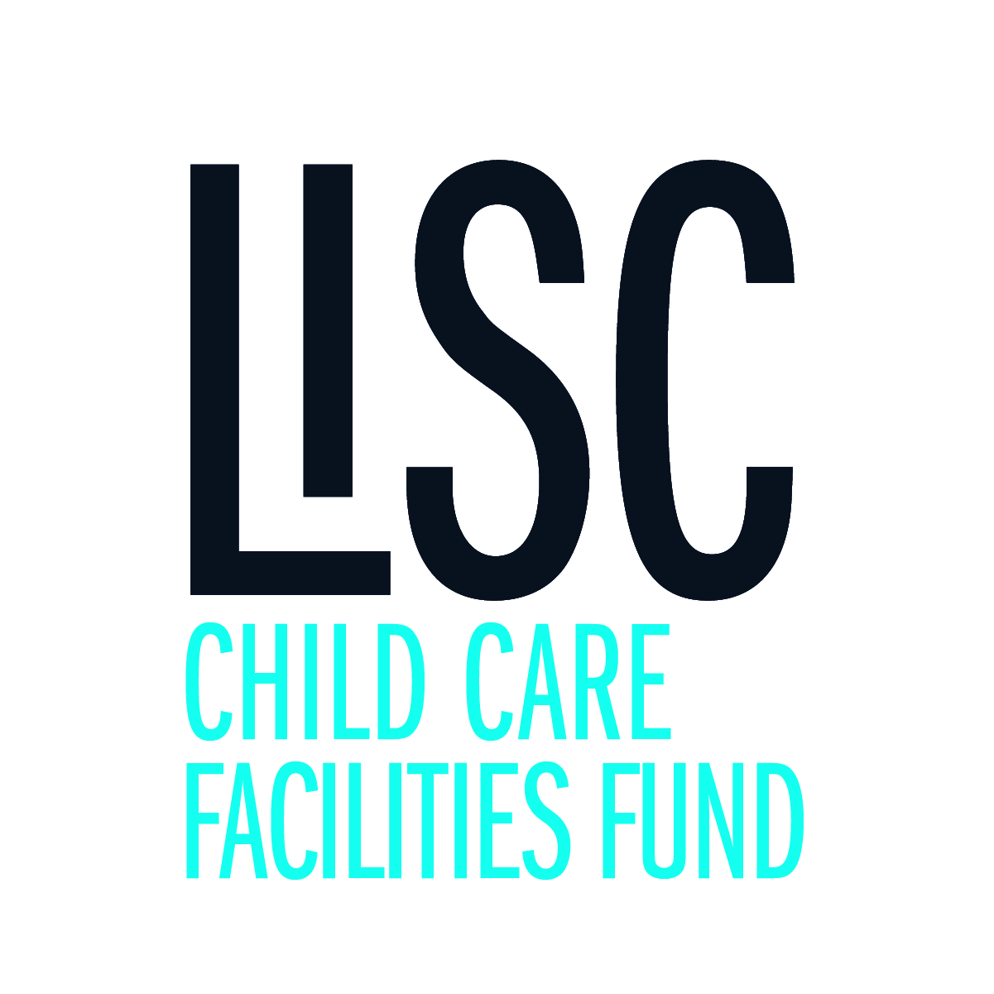

**Early Childhood Care**

**and Education Capital Fund**

**Letter of Intent**

Please include the following elements within your LOI

1. **A brief summary statement** 
   * Who is applying, organization name, and what are you proposing to do with grant funds?
   * How much funding is being requested?
   * Is this a portion of a larger project cost (for example, are you requesting funding for the development of child care space that is part of a larger mixed-use development)?
   * What is your project timeline (planning to completion)?
2. **A statement of need**
   * What issue are you addressing?
   * Who benefits?
3. **A description of project activity**
   * What activities will be involved?
   * What is your approach?
   * Are you collaborating with others?
4. **The outcome of the project (what is the measurable impact)**
   * What do you hope to achieve?
   * How will you know you have achieved these outcomes?
5. **Your capacity to complete the project** 
   * How are you, your staff, and your organization equipped to carry out the proposed activities?
   * Do you have a history with similar projects?
   * Can you carry out the proposed project within a 12 – 24 month time period?
6. **A budget – a general description of the project funding needs**
   * What is the total development cost of the project?
   * What is the amount of your grant request?
   * How did you estimate these costs (did you receive estimates from licensed professionals)?
7. **Contact name and contact information**
8. **A signature**