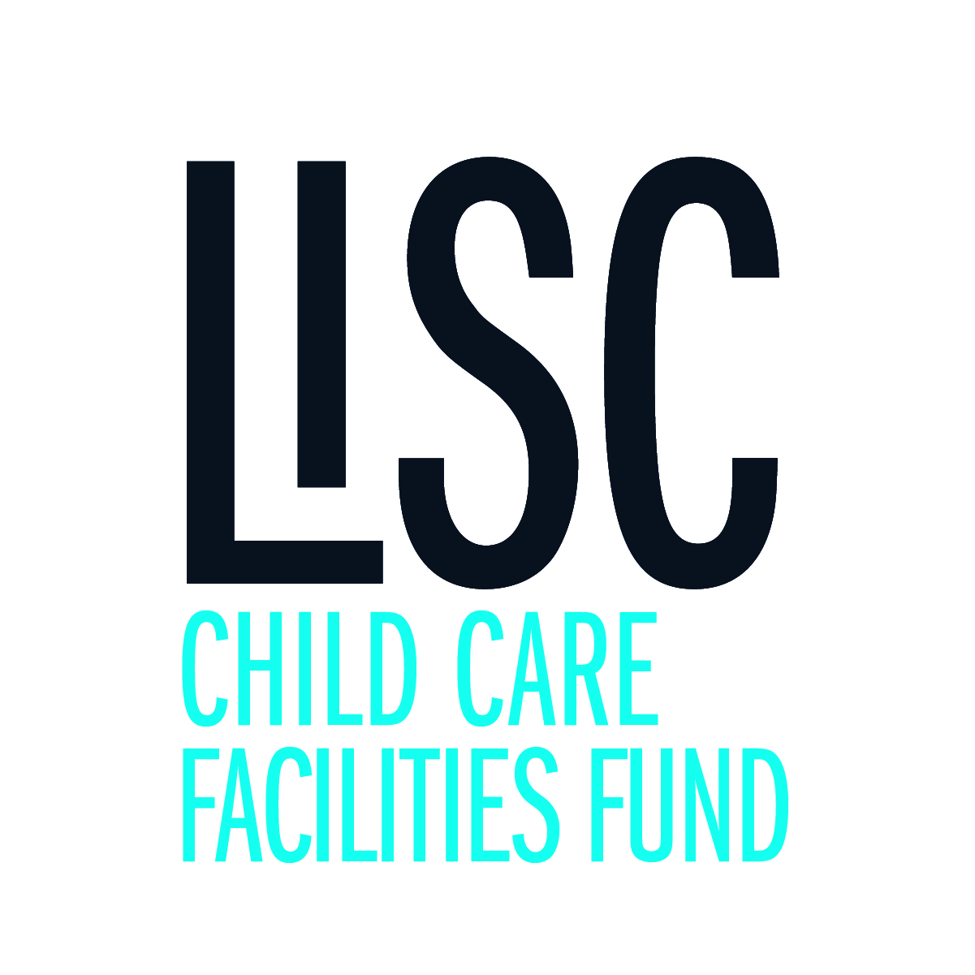

Narrative

Please type your narrative below and then save this file and upload as part of your application process. Be sure to answer all of the following items in the proposal narrative as incomplete applications will not be considered. Proposals should be no more than 4 pages in length.

1. Brief summary of your organization including mission, history, goals and key achievements:

Click or tap here to enter text.

1. Overview of organization’s structure and programs:

Click or tap here to enter text.

1. Summary of key leadership staff and board members including a summary of their qualifications:

Click or tap here to enter text.

1. Describe your proposed project – what do you want to do?

Click or tap here to enter text.

1. Provide an anticipated project budget:

Click or tap here to enter text.

1. Describe your capacity plan to complete the project within the allowed time frame:

Click or tap here to enter text.

1. Complete the following table:

*Describe how your project aligns with priority objectives of: ensuring licensing compliance, addressing major health and safety concerns, or making improvements that will support the program in achieving a higher level of quality or expanding high quality programming. Please refer to grant instructions for further guidance on completing this table, including sample plans.*

|  |  |  |  |  |
| --- | --- | --- | --- | --- |
| **Specific Capital or Planning Request:** | | | | |
| Is issue based on State Licensing Regulation, Environmental Rating Scale (ERS) Indicator, Comprehensive Early Childhood Education (CECE) Program Standard or Other Criteria | Cite specific licensing regulation, ERS indicator, CECE or other specific standard | Details of concern | How will this request address the issue | Estimated time frame and cost for this item |
|  |  |  |  |  |
|  |  |  |  |  |
|  |  |  |  |  |
|  |  |  |  |  |
|  |  |  |  |  |